CHAPTER FOUR

RESULTS AND DISCUSSION

4.1 Introduction
This chapter presents the results obtained from the implementation and testing of the ID Card Generation System. The primary objective of the system is to streamline the process of generating and managing student ID cards efficiently. The following sections provide a detailed explanation of the system’s operation, showcasing the main features and functionalities through various test data and corresponding screenshots.

4.2 Results

4.2.1 Login Page

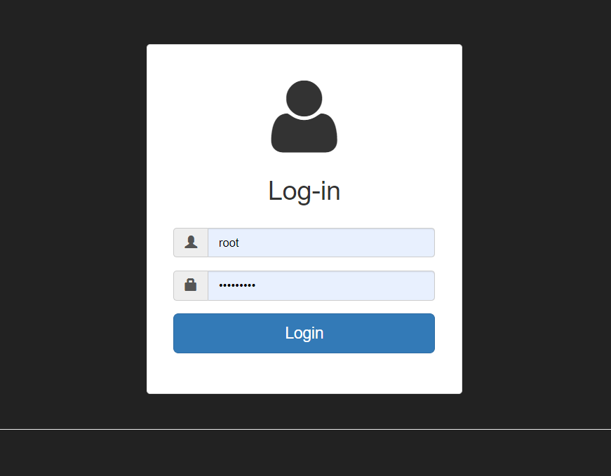
Figure 4.1 LOGIN PAGE
The login page is the entry point of the system where users authenticate their credentials to gain access to the dashboard. The page requires users to input their username and password.

4.2.2 Dashboard

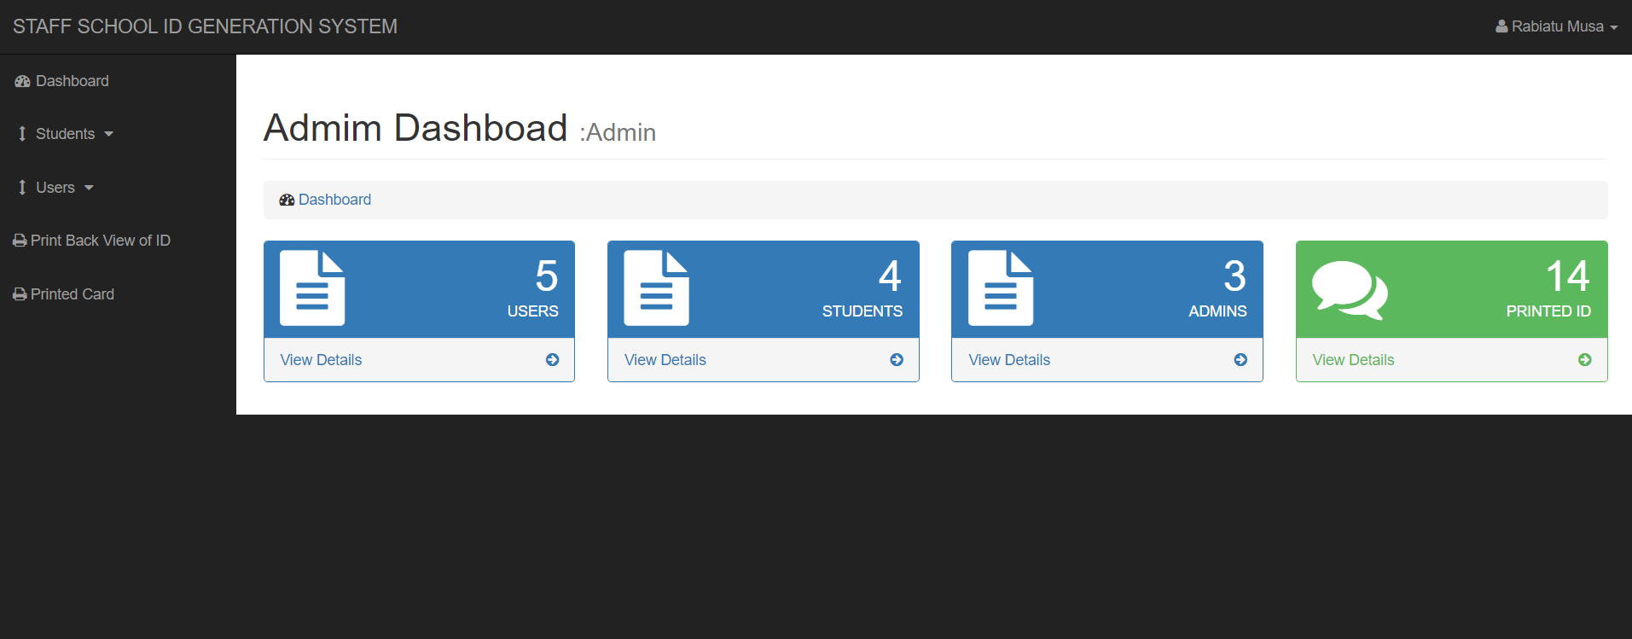
Figure 4.2 DASHBOARD
Upon successful login, users are directed to the dashboard, which serves as the central hub for navigating the system. The dashboard provides quick access to various functionalities such as adding student information, viewing all students, adding users, printing student IDs, and viewing all printed cards.

4.2.3 Add Student Information

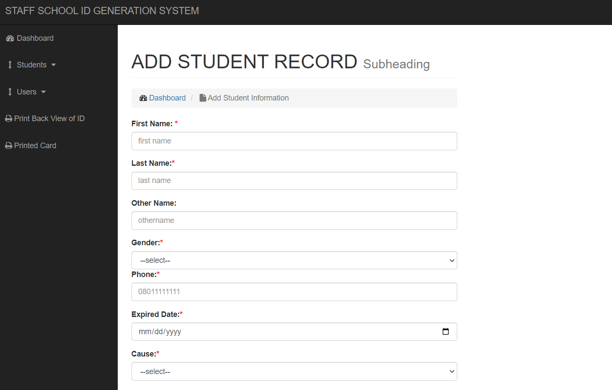
Figure 4.3 ADD STUDENT RECIRD
This feature allows users to input and save new student information into the system. Fields include student name, registration number, department, and other relevant details.

4.2.4 View All Students

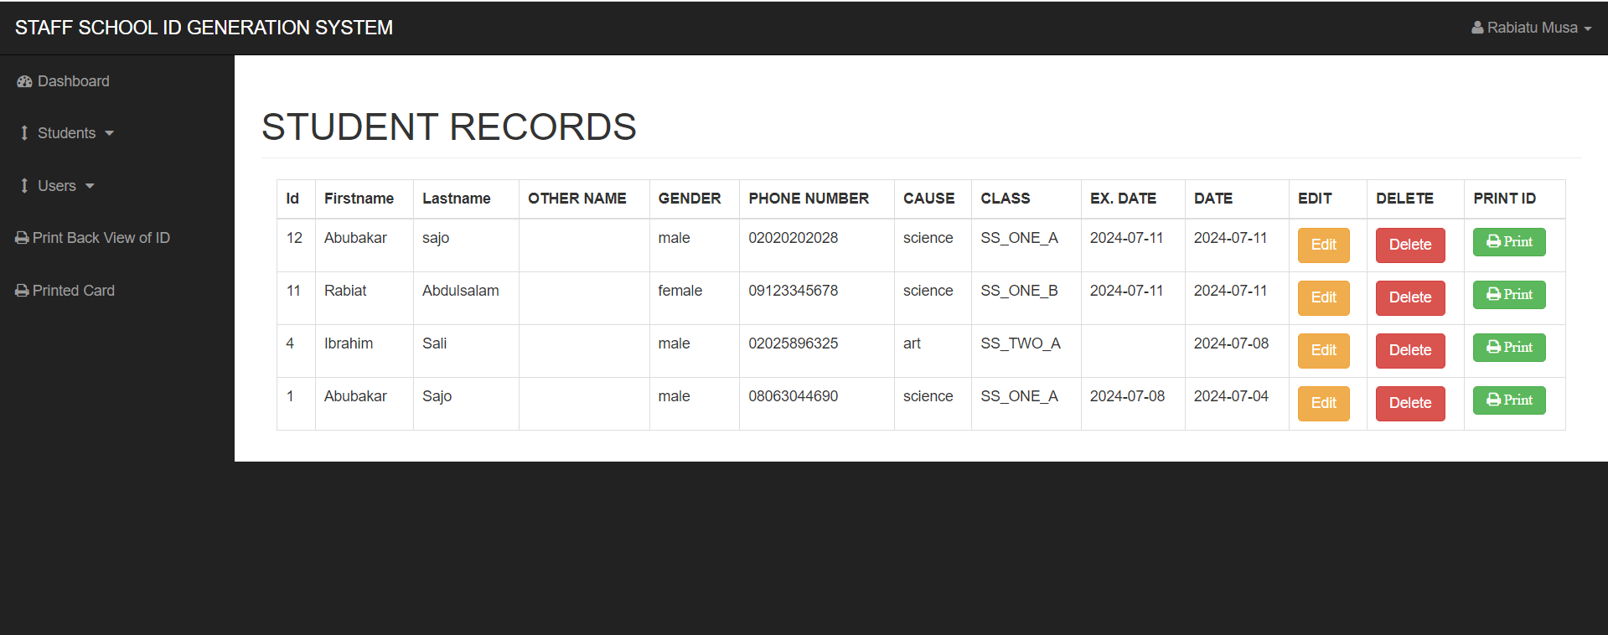
Figure 4.4 VIEW ALL STUDENTS
Users can view a list of all students currently stored in the system. This section displays detailed information about each student and provides options for editing or deleting records.

4.2.5 Add Users

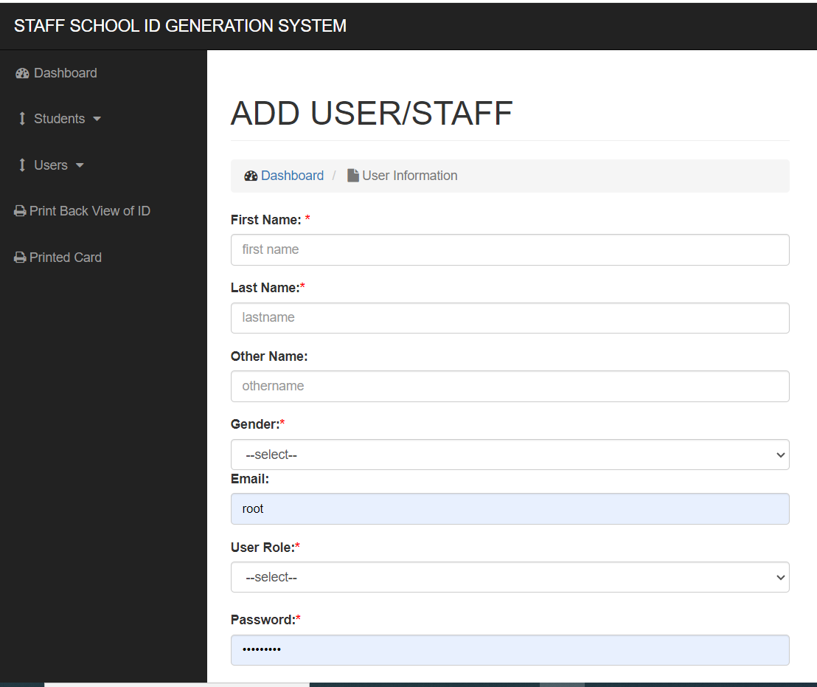
Figure 4.5 ADD USER
The system allows administrators to add new users who can access the ID Card Generation System. This functionality is crucial for managing user roles and permissions.

4.2.6 Print Student ID

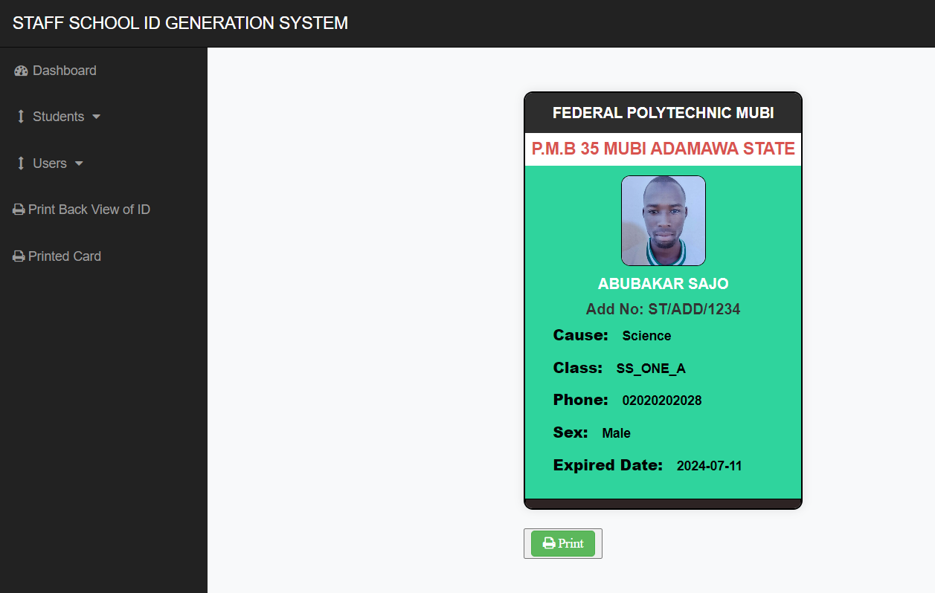
Figure 6 PRINT STUDENT ID
This feature enables users to print the ID cards for students. The ID card includes essential details such as the student’s name, registration number, department, and photograph.

4.2.7 View All Printed Cards

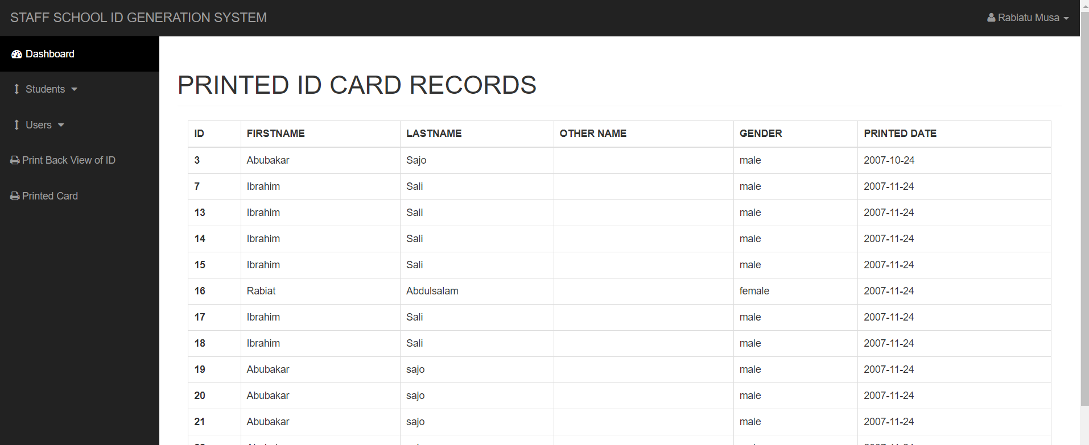
Users can view a list of all printed ID cards, which helps in tracking and managing the distribution of ID cards to students.

4.3 Discussion
The results from the implementation and testing of the ID Card Generation System demonstrate its efficacy in managing the process of generating student ID cards.
- Login Page: The login page ensures that only authorized users can access the system, providing a secure environment for managing student data.
- Dashboard: The dashboard is intuitive and user-friendly, enabling users to navigate seamlessly between different functionalities.
- Add Student Information: This feature simplifies the data entry process, allowing for quick and accurate input of student details.
- View All Students: The ability to view all students in a centralized list facilitates easy management and retrieval of student information.
- Add Users: Administrators can efficiently manage user access and permissions, ensuring that only authorized personnel can perform specific actions within the system.
- Print Student ID: The ID printing feature produces professional and standardized ID cards, which are essential for student identification and campus security.
- View All Printed Cards: Tracking printed ID cards ensures accountability and prevents duplication or loss of ID cards.

4.4 User Manual

Installation Steps
- System Requirements:
  - Operating System: Windows
  - Web Server: Apache or Nginx
  - PHP: Version 7.4 and above
  - Database: MySQL
- Download the System:
  - Obtain the ID Card Generation System from the repository or source provided.
- Setup the Environment:
  - Install and configure the web server.
  - Install and configure PHP and MySQL.
  - Create a new database for the system.
- Deploy the System:
  - Extract the system files into the web server’s root directory.
  - Configure the database connection in the configuration file.
- Run the System:
  - Open a web browser and navigate to the system’s URL.
  - Follow the on-screen instructions to complete the installation process.

Operation Steps
- Login:
  - Enter your username and password on the login page.
  - Click the “Login” button to access the dashboard.
- Add Student Information:
  - Navigate to “Add Student” from the dashboard.
  - Fill in the required student details.
  - Click “Save” to store the information.
- View All Students:
  - Navigate to “View All Students” from the dashboard.
  - Browse through the list of students and use the search function if needed.
- Add Users:
  - Navigate to “Add Users” from the dashboard.
  - Enter the new user’s details and assign appropriate roles.
  - Click “Save” to add the user.
- Print Student ID:
  - Navigate to “Print Student ID” from the dashboard.
  - Select the student whose ID you want to print.
  - Click “Print” to generate and print the ID card.
- View All Printed Cards:
  - Navigate to “View All Printed Cards” from the dashboard.
  - Review the list of printed cards to ensure all students have received their ID cards.

